**AUTRUI**

**CS 307**

**Team 10**

Mihir Jham

Rishabh Mittal

Karan Kalwani

Manmohit Sehgal

Ankit Kapur

**Sprint 3 – Planning Document**

**Sequence Diagrams:**

1. ***Global Impact:***

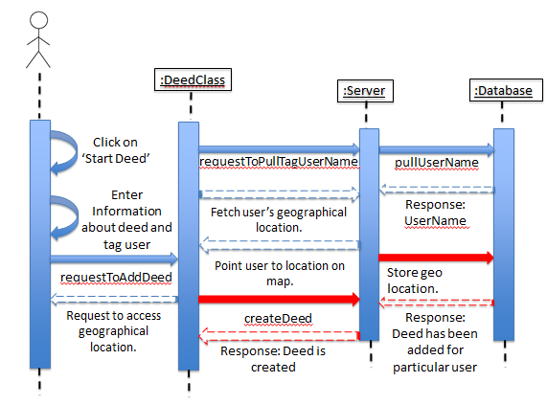

The sequence diagram above shows how the app retrieves the user’s geographical location to be able to tag and show his/her impact on a world map. The idea is to keep track of the location where the said user is completing his/her deed. So once the user has a sizable chunk of deeds that are followed up by other users in many different parts of the world, then the ‘Global Impact’ will display the global footprint of the movement. This will be using a tool called D3.js. It is a JavaScript library for manipulating documents based on set of data, which in our case is the location of the users. This, of course, will only be tracked once the user has provided the necessary permissions.

1. ***Editing existing data:***

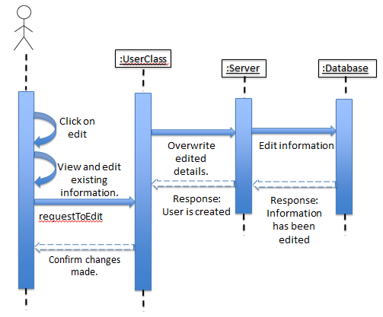

The sequence diagram above shows how the app enables the user to update and/or edit data that has already been input by him/her before. This part of app is extremely important as there are often details that the user might want to remove, or add when using the app. The user basically taps the edit icon and then is shown an editable template with all his/her data. Then the user can make the required changes and the same is added in the database. A confirmation message of the update is then shown to the user.

1. ***Movement Creation:***

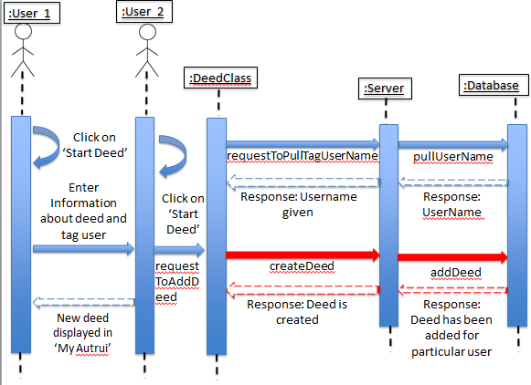

The diagram above describes the user to user interaction that essentially forms what refer to as a movement. In this case the first user starts a deed, describes and provides the information of the second user that is involved in the deed. A movement occurs when the second user basically starts a new deed paying the initial deed forward to a third user. The process repeats when every added user pays the deed forward to another user. Users can be repeated in a movement as long as they aren’t being ‘paid back’.

1. ***Movement Visualization:***

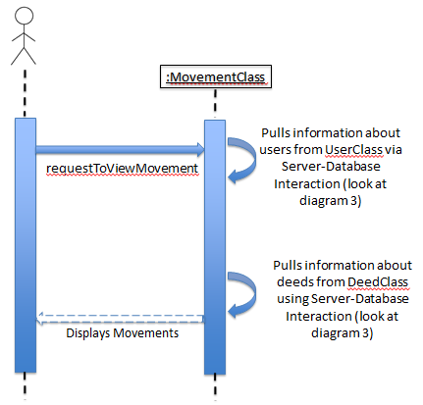

The diagram above, describes how the app responds in order to display the user the movements that he/she is part of. The user basically sends a request to view the movements. The movement class responds by doing the actions shown in diagram 3 and responds with the required information back to the user.

1. ***Push notifications:***

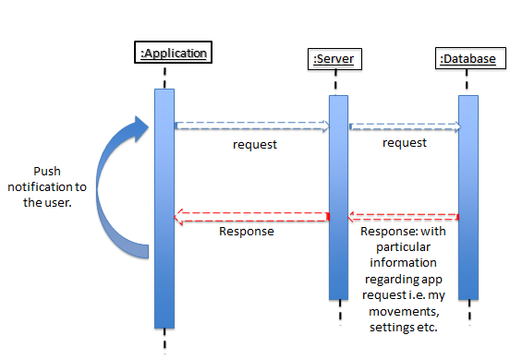

The diagram above describes the apps response to the user in the form of push notifications (when enabled) under specific situations. Scenarios like when someone has deed for the said user, or if there is an updated list of pre-defined deeds, results in the app responding with a push notification.

**Task Description and Distribution:**

As we transition onto the third sprint of our project, we as a team have reached a stage where do not have any concrete distribution of the tasks at hand. Instead, we have a lot of tasks overlapping among all the team members as everyone is working on pretty much all parts of the project. This is specially highlighted in terms of getting the user interface up to the mark and fixing bugs, as they will not be held back to be completed by someone in particular. The table below highlights how the tasks will be divided in general:

|  |  |  |
| --- | --- | --- |
| **#** | **Task** | **Task Owner(s)** |
| **1.** | ***Global Impact:*** The idea is to keep track of the location where the said user is completing his/her deed. So once the user has a sizable chunk of deeds that are followed up by other users in many different parts of the world, then the ‘Global Impact’ will display the global footprint of the movement. This will be using a tool called D3.js. It is a JavaScript library for manipulating documents based on set of data, which in our case is the location of the users. This, of course, will only be tracked once the user has provided the necessary permissions. | Mihir Jham, Manmohit Sehgal.  Estimated time: 20 – 25 hours per week. |
| **2.** | ***Movement creation:*** Until now we have been successful in creating deeds and connecting the users with their respective deeds. We were able to create movements, in a way such that each new deed created by the user is added to the total number of deeds – forming a movement. Though this is a good start, we are yet to refine its functionality and management. The next objective is to convert these small deeds into movements and be able to add a ‘tree’ of users to multiple deeds forming a ‘movement’. | Mihir Jham, Manmohit Sehgal & Ankit Kapur.  Estimated time: 20 – 25 hours per week. |
| **3.** | ***Movement visualization:*** Once the algorithm of linking multiple users to multiple deeds that are initiated by a single deed is complete, we have to work on creating a visualization that the user can understand. We were able to represent the different users as small green circles connected to the main user (a blue circle), connected via a deed, shown by a straight line. We still need to make this more intuitive. Also, we are planning to use a JavaScript library called D3.js, which will allow the users to interact with the visualization and the visualization will also have a more refined, polish look. | Mihir Jham, Rishabh Mittal & Ankit Kapur.  Estimated time: 20 – 25 hours per week. |
| **4.** | ***Push notification:*** The idea is to provide notifications to the user regarding specific actions occurring in the app. Things like when the user is added to a movement, or when the list of predefined deeds is updated the user should receive a push notification. We did start working on the push notifications, but fell short as this comes at a lot later stage of our app. We just got done with linking two users in a movement, and didn’t have anything to ‘push notify’ to the said user. We plan to further work on this as part of our third sprint. | Manmohit Sehgal & Ankit Kapur.  Estimated time: 20 – 25 hours per week. |
| **5.** | ***Improving the user interface:*** Our aim was to make our app look more aesthetically pleasing. We worked on making different buttons and added new colors to make it more user friendly. For now we have tested around with a lot of different backgrounds, colors and shapes for the buttons. As the UI design is an ongoing process, we aim to keep developing this as we progress with the app design. We will be incorporating the use of fragments to improve transitions. | Rishabh Mittal & Karan Kalwani  Estimated time: 20 – 25 hours per week. |
| **6.** | ***Deed creation and management:*** The creation of deeds and how it is linked to other users, forming a movement is at its elementary stage where we are able to simply add and remove deeds. We need to make sure this is done the way we had intended to i.e. by connecting the two users with a deed and the second user is able to follow up on that deed, and so on. The way our deeds are managed is integral to how our movements will be formed and so we have to make a few changes from our initial implementation. | Mihir Jham, Manmohit Sehgal & Karan Kalwani.  Estimated time: 20 – 25 hours per week. |
| **7.** | **Adding the Pay-it-Forward Mechanism*:*** Our application is based around the idea of the Pay-it-Forward movement and we have to implement a way to notify that a good deed has been done to them. This will help create incentive to keep coming back to the app and continue growing the movements. It will also directly make use of the Push Notifications feature of smartphone apps. | Mihir Jham, Manmohit Sehgal & Ankit Kapur.  Estimated time: 20 – 25 hours per week. |
| **8.** | ***Commenting:*** Having already commented a lot of our code, we aim to identify the key portions and add commenting where it might seem necessary. This will be imperative in order to make sure the smooth transitioning of new members who may join the team to take the project forward. | All. |
| **9.** | ***Weekly meetings:*** We found our initiative to meet on a weekly to be an effective measure to have the app successfully address all the criteria we had for the first sprint. We aim to continue doing so this time too. | All.  Estimated time: 10 – 12 hours per week. |

**User Stories:**

***Use Cases Tasks***

**User Story:**

As a user, I want to be able to view how the movement that I am a part of has spread around the different locations of the world, and be able to view my location too.

**Task Owner:** Mihir Jham

Using D3.js, write a script that can visually plot the different locations that the different users are spread around the world.

**Estimated time:** 20 hours

**Task Owners:** Manmohit Sehgal & Ankit Kapur

Using Java, write code to seek permission from user to retrieve geographic location data. Parse the data using server-side of the application.

**Estimated time:** 15 hours

**User Story:**

As a user, I want to be able to view the movements I am part of and be able to visualize the same graphically.

**Task Owners:** Mihir Jham & Rishabh Mittal

Develop the server-side infrastructure to enable multiple users to be connected to each other and form a movement out of one starting deed.

**Estimated time:** 25 hours

**Task Owners:** Manmohit Sehgal & Ankit Kapur

Develop client-side user interface to showcase the connections made in the server-side for the movements. This interface will be in the form of tree diagrams.

**Estimated time:** 25 hours

**User Story:**

As a user, I want to be push notified whenever I am added to a movement, or receive any other updates.

**Task Owners:** Manmohit Sehgal

Develop the server-side functionality of the information received by the user to be counted and be displayed to the user.

**Estimated time:** 15 hours

**Task Owners:** Karan Kalwani

Develop client-side user interface to display the notification counter to the user. When tapped, the user should be shown the new movement he/she is a part of.

**Estimated time:** 15 hours

**User Story:**

As a user, I want to have a good user experience when using the app. The app design should not be boring and be vibrant.

**Task Owners:** Rishabh Mittal & Karan Kalwani

Develop the client-side infrastructure using AndroidXML to provide a good user interface. Make use of fragments to provide smooth transitions between modules. Provide consistent layouts and color schemes.

**Estimated time:** 30 hours

…………………………………………………………………………………………………………………………………………………….